FINAL PROJECT
Humidity & Temperature Monitor with DHT11 & STM32 Microcontroller

BY:- Utkarsh Patel
G11 ES & IOT
INSTRUCTOR: Kiran K. Reddy

Objective:
The primary objective of this project is to design and implement a system to monitor humidity and temperature using a DHT11 sensor interfaced with an STM32F103C8 microcontroller. The project aims to display the real-time environmental data on a 16x2 LCD, leveraging the features of the STM32 microcontroller and the DHT11 sensor. This system can be used in various applications, including weather monitoring, industrial environments, greenhouses, and smart home systems.
Components Required:
Hardware:
- STM32F103C8 Microcontroller: The STM32F103C8, commonly known as the Blue Pill, is a 32-bit ARM Cortex-M3 microcontroller. It features:
- Clock speed: Up to 72 MHz
- Flash memory: 64 KB
- SRAM: 20 KB
- Peripherals: GPIO, UART, I2C, SPI, ADC, and PWM
- DHT11 Sensor: The DHT11 is a low-cost sensor for measuring temperature and humidity. Features include:
- Temperature range: -20°C to 60°C (±2°C accuracy)
- Humidity range: 20% to 90% RH (±5% accuracy)
- Communication: Single-wire protocol
- 16x2 LCD Display: The 16x2 LCD is a display module capable of showing 16 characters per row over 2 rows. It operates using:
  - 4-bit or 8-bit communication modes
  - Control pins: RS (Register Select) and EN (Enable)
  - Data pins: D4 to D7 (for 4-bit mode)
- Connecting Wires (for connections)
- ST Link V2 Programmer
- 5V Power Supply
Software:
- STM32CubeProgrammer
- Arduino IDE

Circuit Connections:
The connections are made as follows:
DHT11 Sensor:
- VCC: Connect to 3.3V pin of the STM32F103C8.
- GND: Connect to GND.
- Data: Connect to GPIO pin PA0.
16x2 LCD:
- RS: Connect to PB11.
- EN: Connect to PB10.
- D4-D7: Connect to PA4, PA3, PA2, and PA1 respectively.
- VCC: Connect to 5V.
- VSS: Connect to GND.
- V0: Connect to a 10K potentiometer for contrast control.

Implementation:
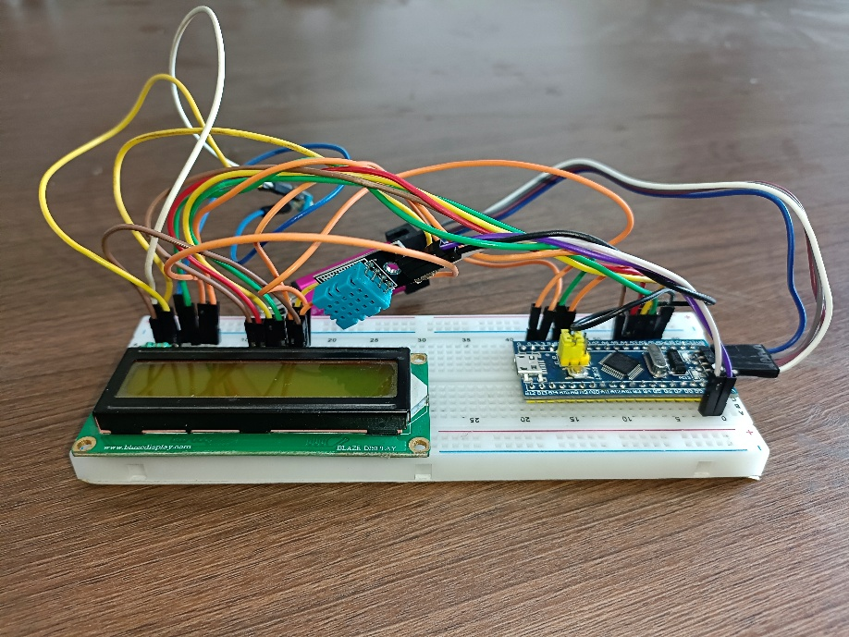
Circuit Diagram:
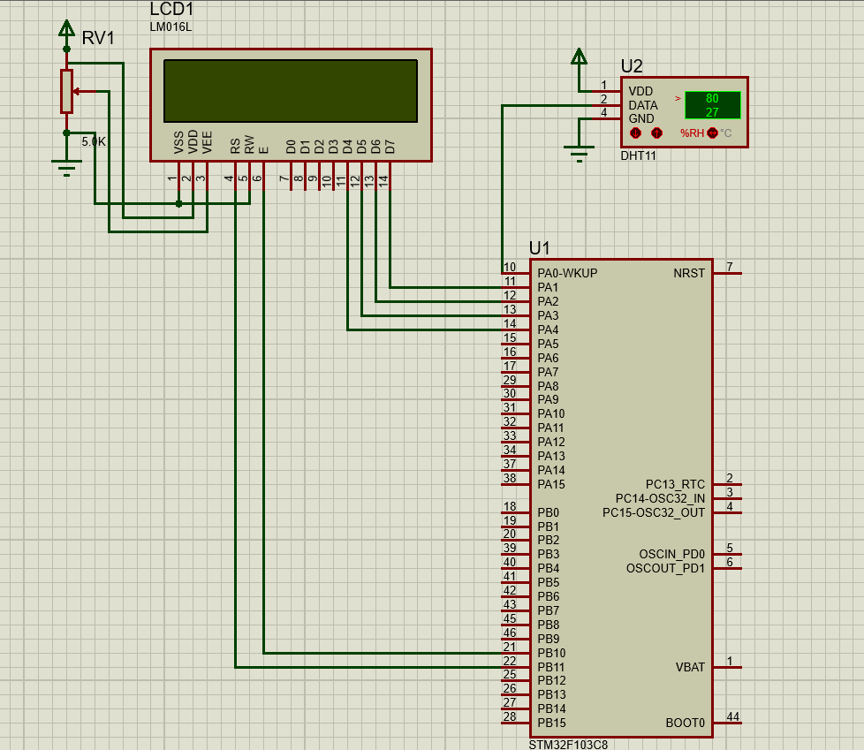

STM32F108C8T6 Program on Arduino IDE:
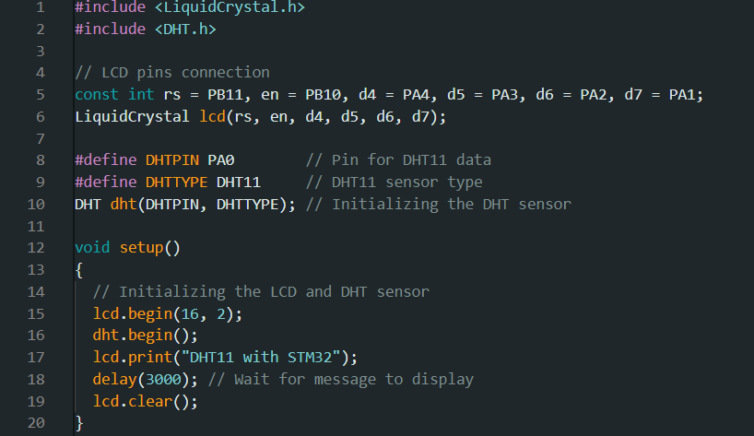
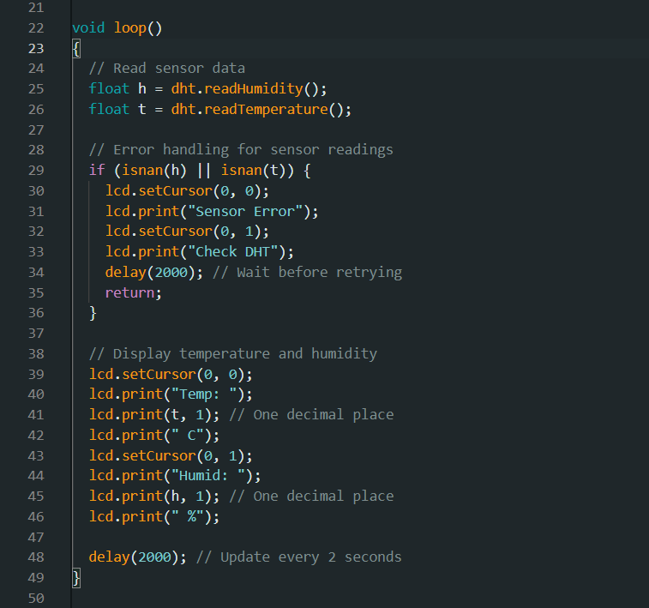
Testing and Results
- Power the Circuit:
  - Connect the STM32F103C8 to a 5V power source or USB.
- Display Data:
  - Observe the temperature and humidity displayed on the LCD in real-time.
- Error Handling:
  - If the sensor fails, the LCD displays "Error Reading".
Applications
- Weather Stations
- Greenhouse Monitoring
- Industrial Environment Monitoring
- Smart Home Automation

